AWS EC2 & EBS INFRASTRUCTURE REPORT

Status: Volume successfully created

EBS Volume Creation Settings
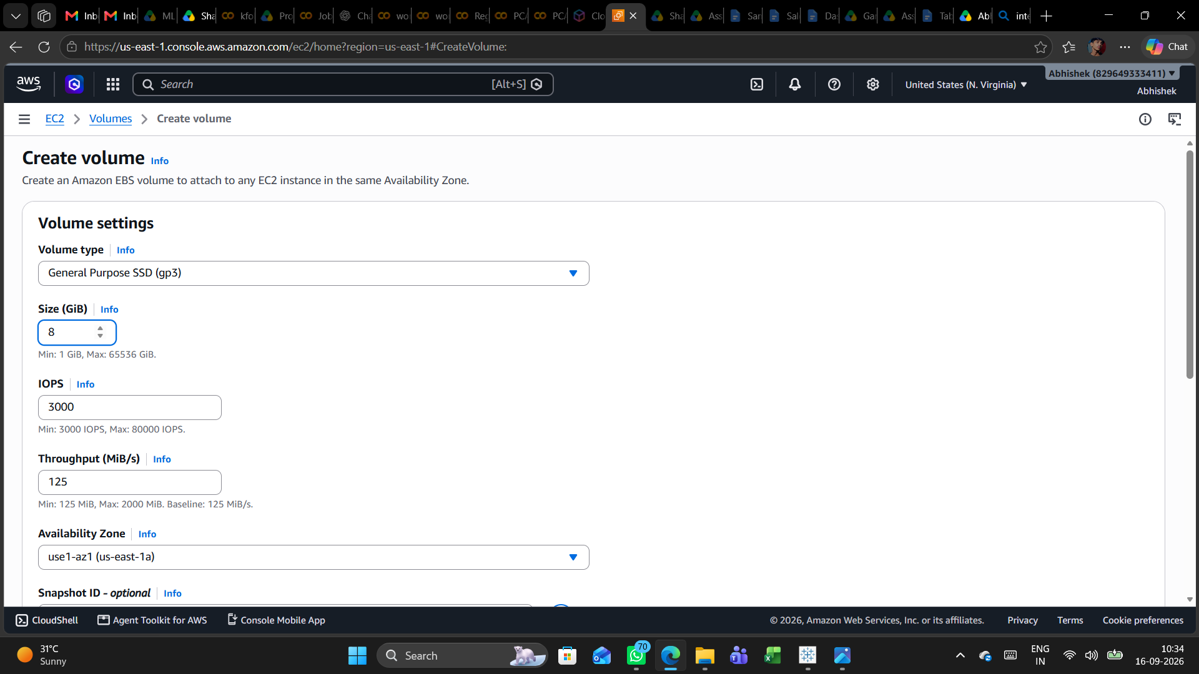

Summary: The first screenshot shows the main EBS configuration page: gp3, 8 GiB, 3,000 IOPS, 125 MiB/s throughput, and Availability Zone

2. Snapshot, Encryption, Tags and Creation
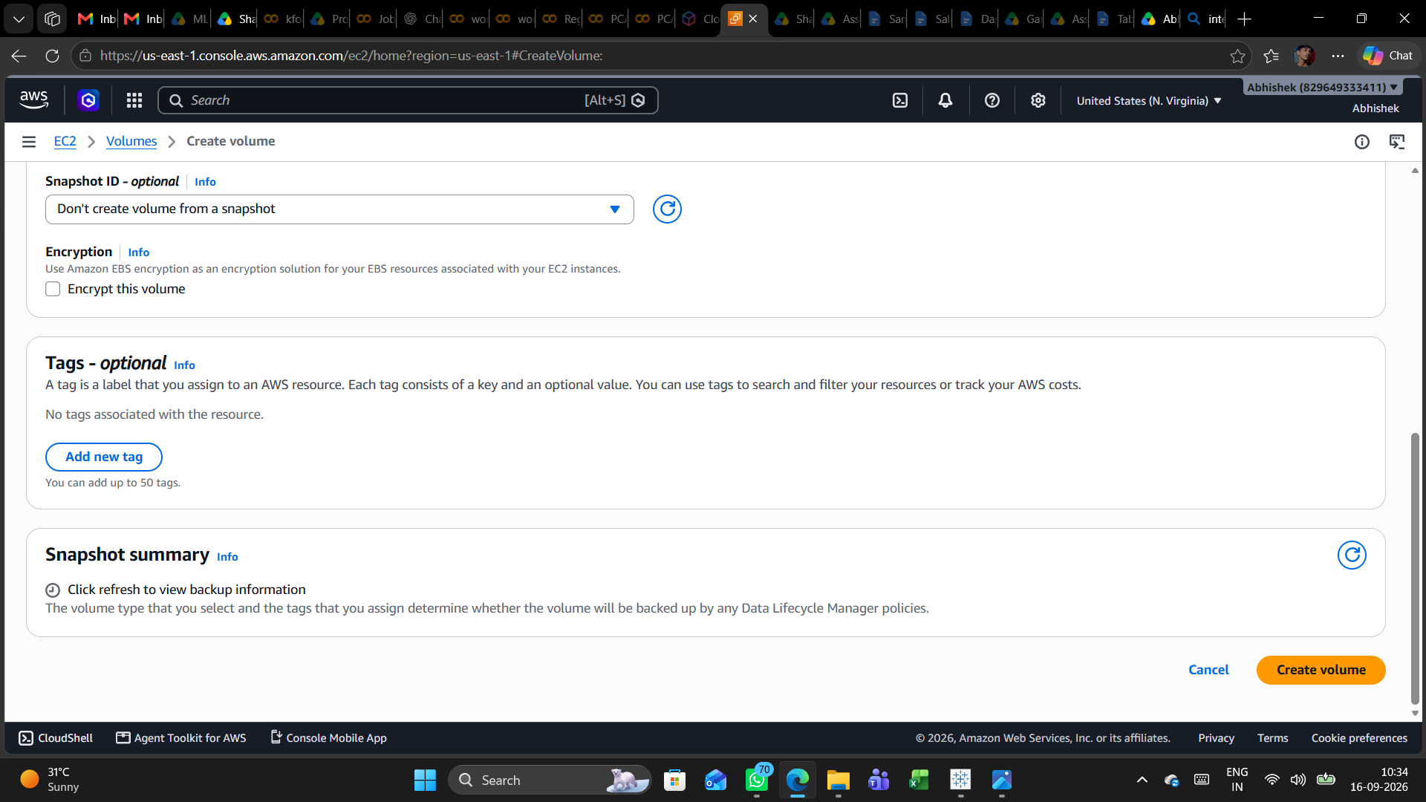

Summary: The second screenshot shows the lower creation form. No snapshot is selected, encryption is unchecked, and no tags are associated.

3. Successful EBS Volume Creation
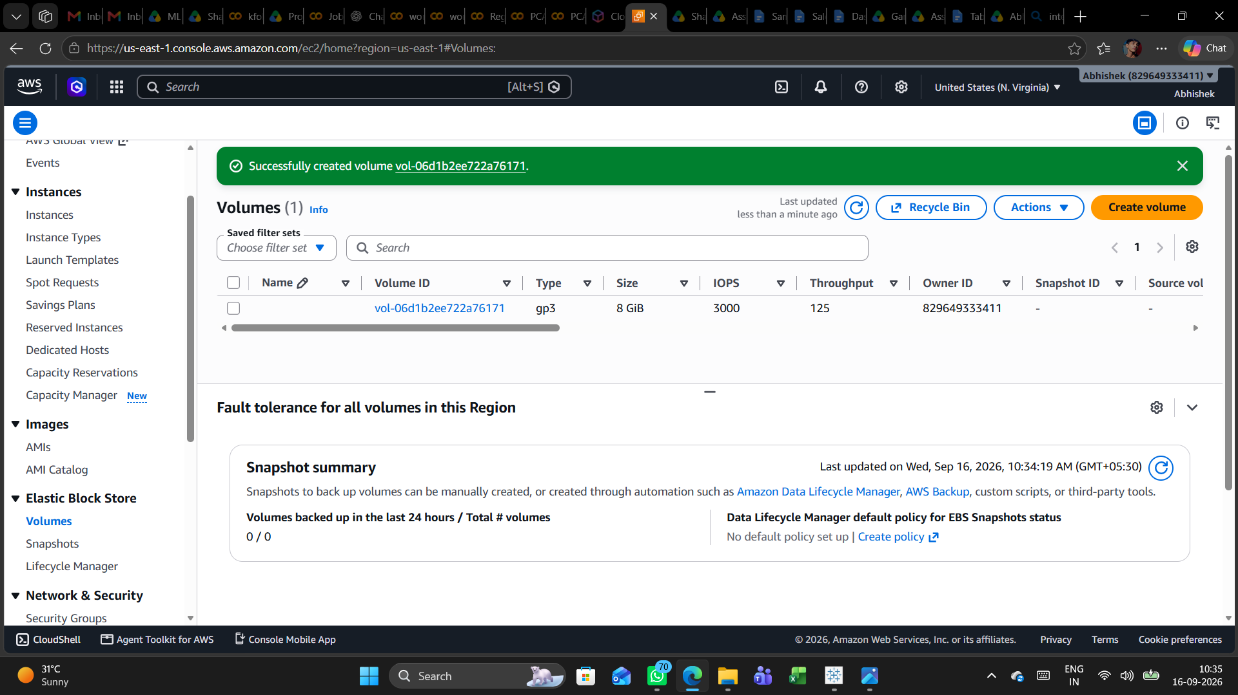
Summary: The final screenshot verifies successful creation and displays the new volume in the EC2 Volumes list.

4. Conclusion
The screenshots document successful provisioning of an 8 GiB gp3 EBS volume in us-east-1 / use1-az1, configured for 3,000 IOPS and 125 MiB/s throughput. The main governance items to review are encryption, tagging, backup policy, and attachment/configuration for the intended workload.

